**# Jawaban Latihan 11**

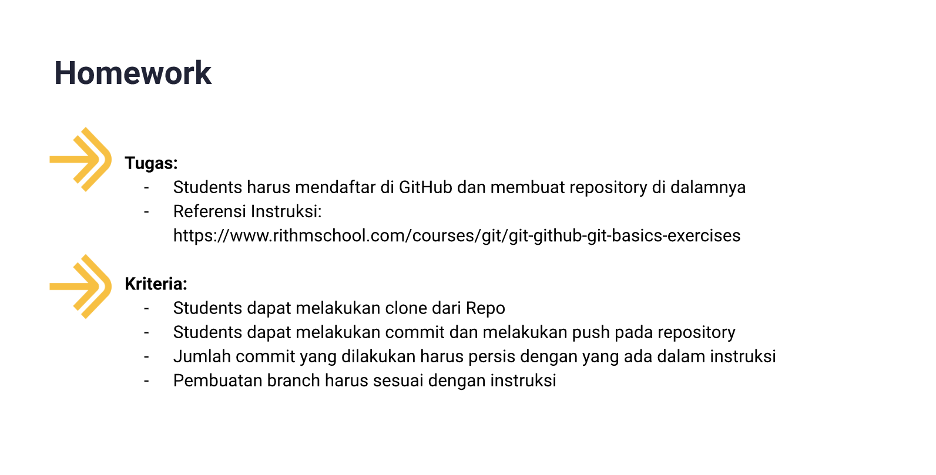

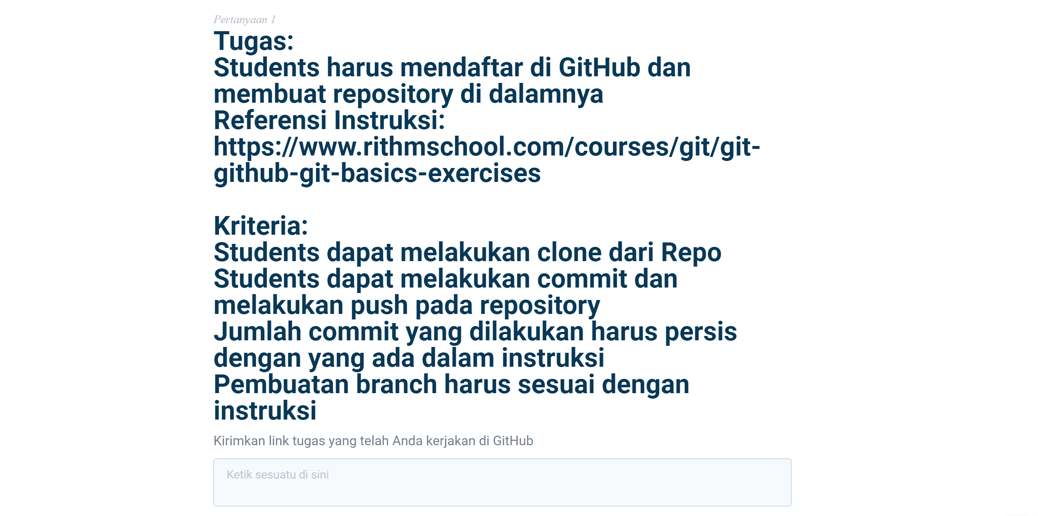

|  |
| --- |
| Tugas:Students harus mendaftar di GitHub dan membuat repository di dalamnyaReferensi Instruksi: <https://www.rithmschool.com/courses/git/git-github-git-basics-exercises>Kriteria:Students dapat melakukan clone dari RepoStudents dapat melakukan commit dan melakukan push pada repositoryJumlah commit yang dilakukan harus persis dengan yang ada dalam instruksiPembuatan branch harus sesuai dengan instruksiKirimkan link tugas yang telah Anda kerjakan di GitHub |

## Students (an. Junaedih) sudah mendaftar di GitHub dan sudah membuat repository di dalamnya.

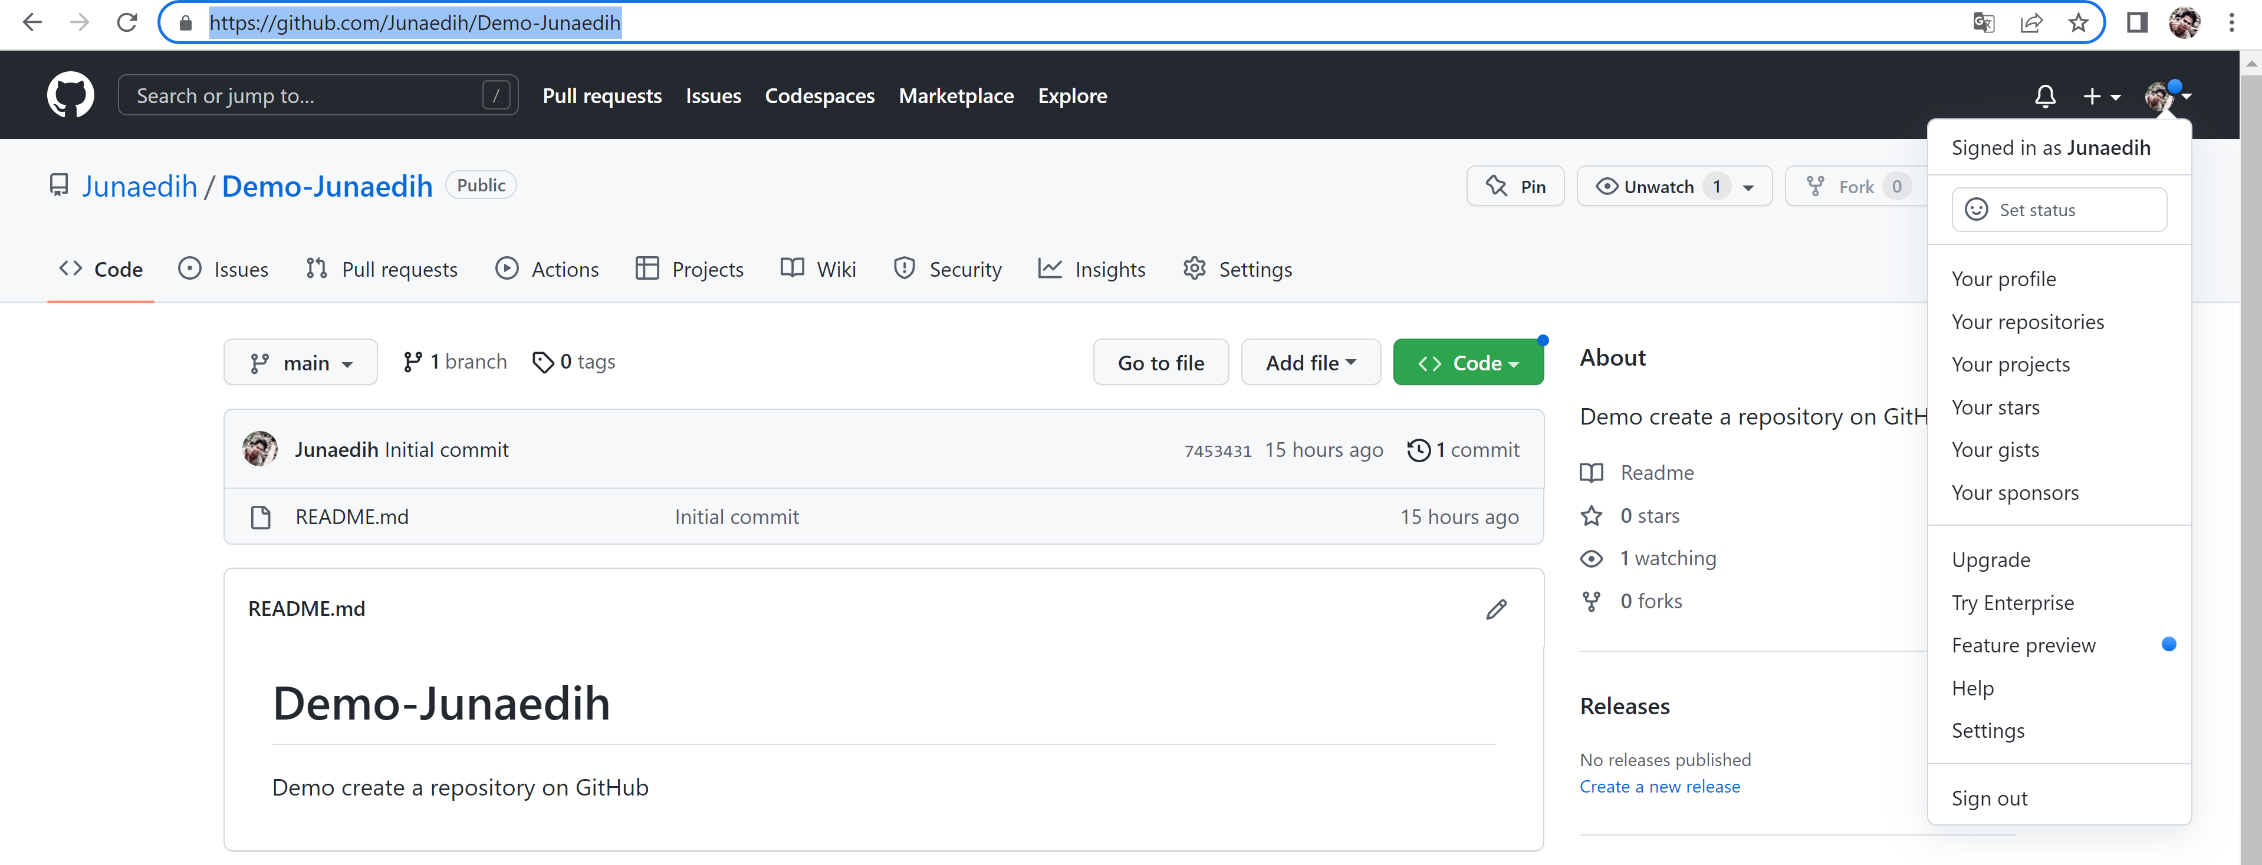

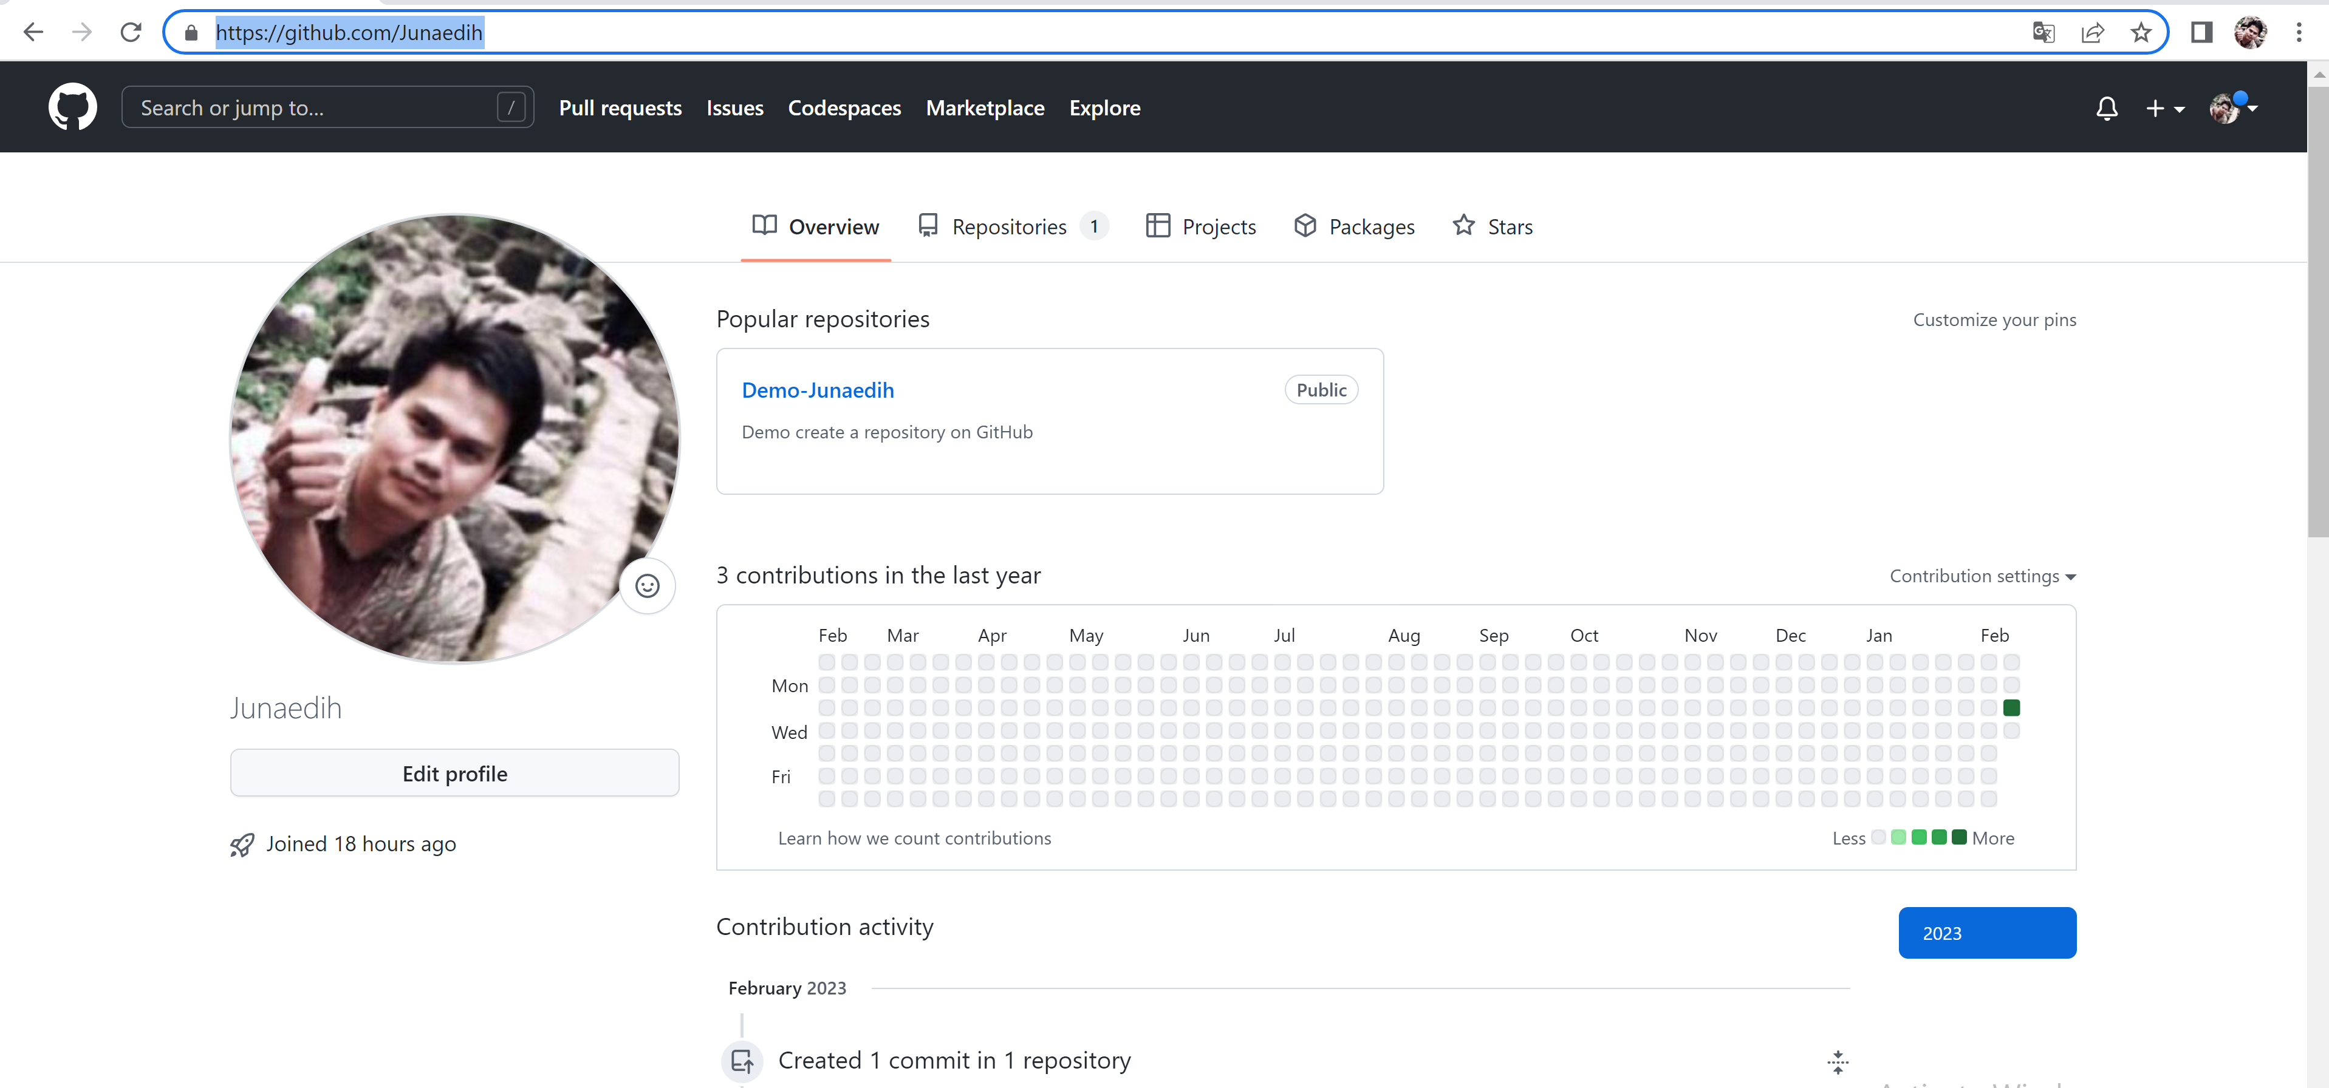

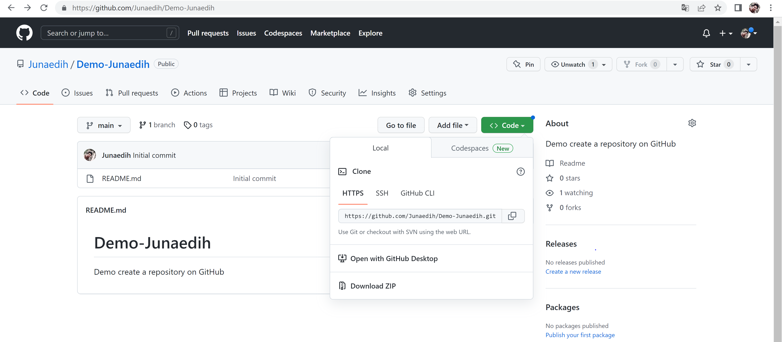

<https://github.com/Junaedih/Demo-Junaedih.git>

## Referensi Instruksi: <https://www.rithmschool.com/courses/git/git-github-git-basics-exercises>

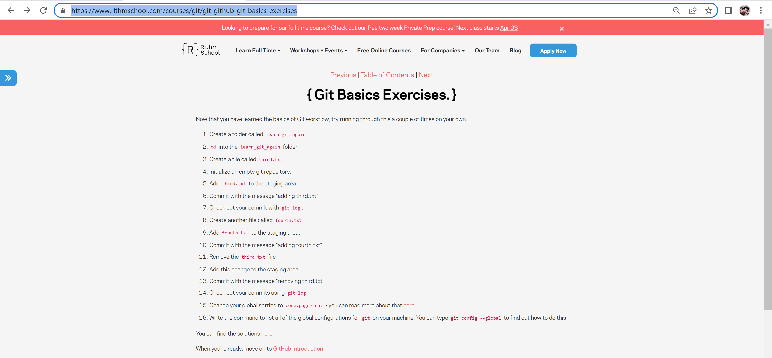

Now that you have learned the basics of Git workflow, try running through this a couple of times on your own:

# { Git Basics Exercises. }

1. Create a folder called learn_git_again.
2. cd into the learn_git_again folder.
3. Create a file called third.txt.
4. Initialize an empty git repository.
5. Add third.txt to the staging area.
6. Commit with the message "adding third.txt".
7. Check out your commit with git log.
8. Create another file called fourth.txt.
9. Add fourth.txt to the staging area.
10. Commit with the message "adding fourth.txt"
11. Remove the third.txt file
12. Add this change to the staging area
13. Commit with the message "removing third.txt"
14. Check out your commits using git log
15. Change your global setting to core.pager=cat - you can read more about that [here](https://git-scm.com/book/en/v2/Customizing-Git-Git-Configuration).
16. Write the command to list all of the global configurations for git on your machine. You can type git config --global to find out how to do this

## Kriteria:

## Students dapat melakukan clone dari Repo

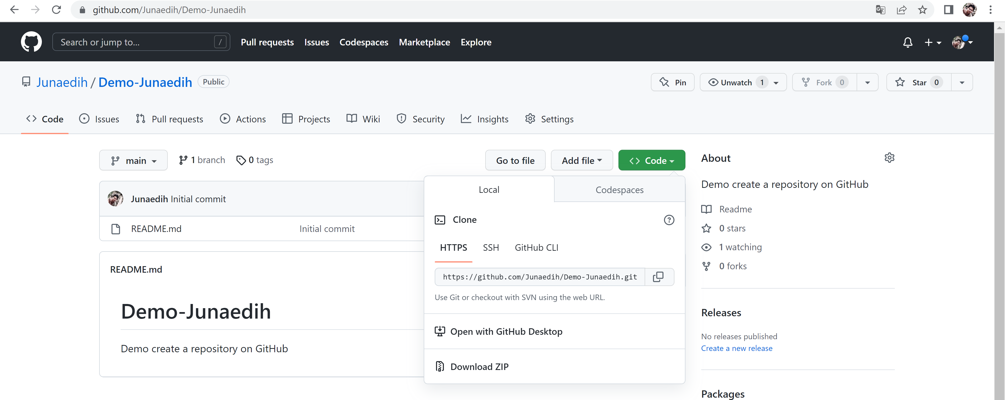

*https://github.com/Junaedih/Demo-Junaedih.git*

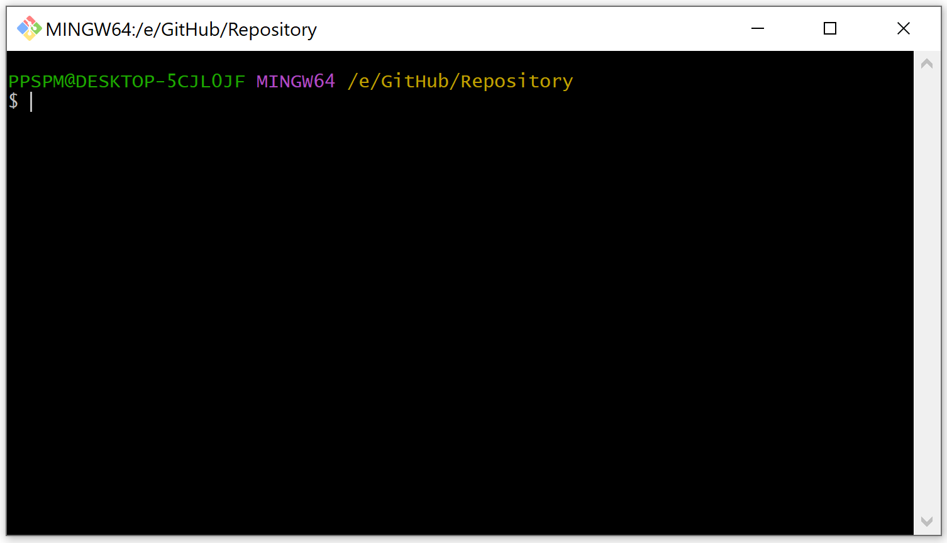

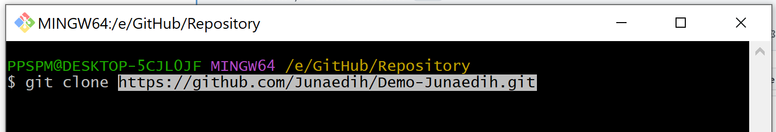

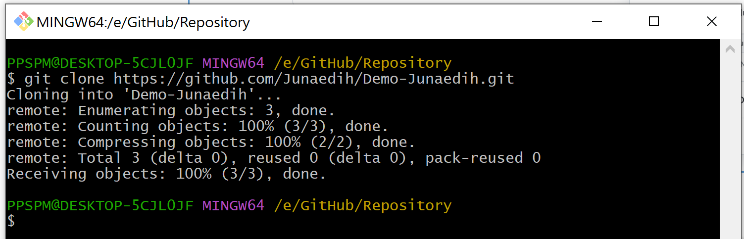

## Students dapat melakukan commit dan melakukan push pada repository

## Jumlah commit yang dilakukan harus persis dengan yang ada dalam instruksi

## Pembuatan branch harus sesuai dengan instruksi

## Kirimkan link tugas yang telah Anda kerjakan di GitHub

1. Create a folder called learn_git_again.

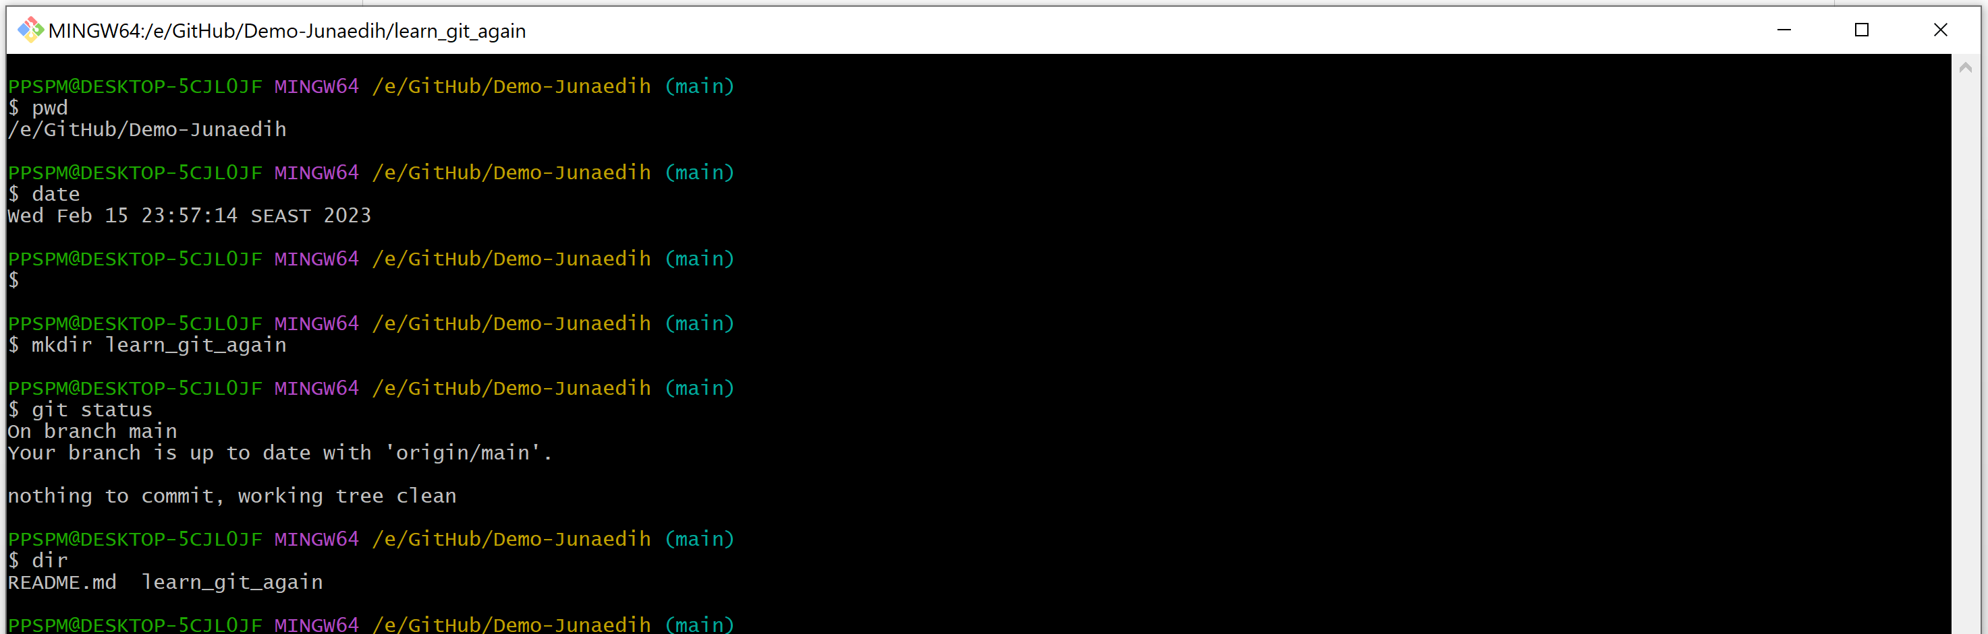

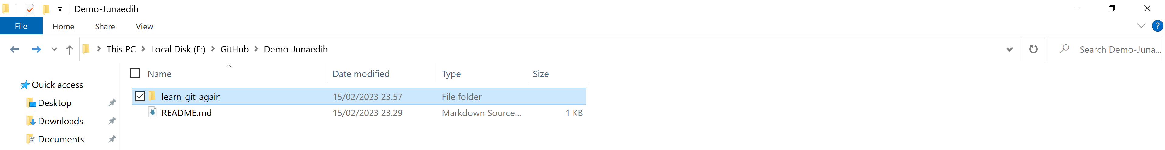

1. cd into the learn_git_again folder.

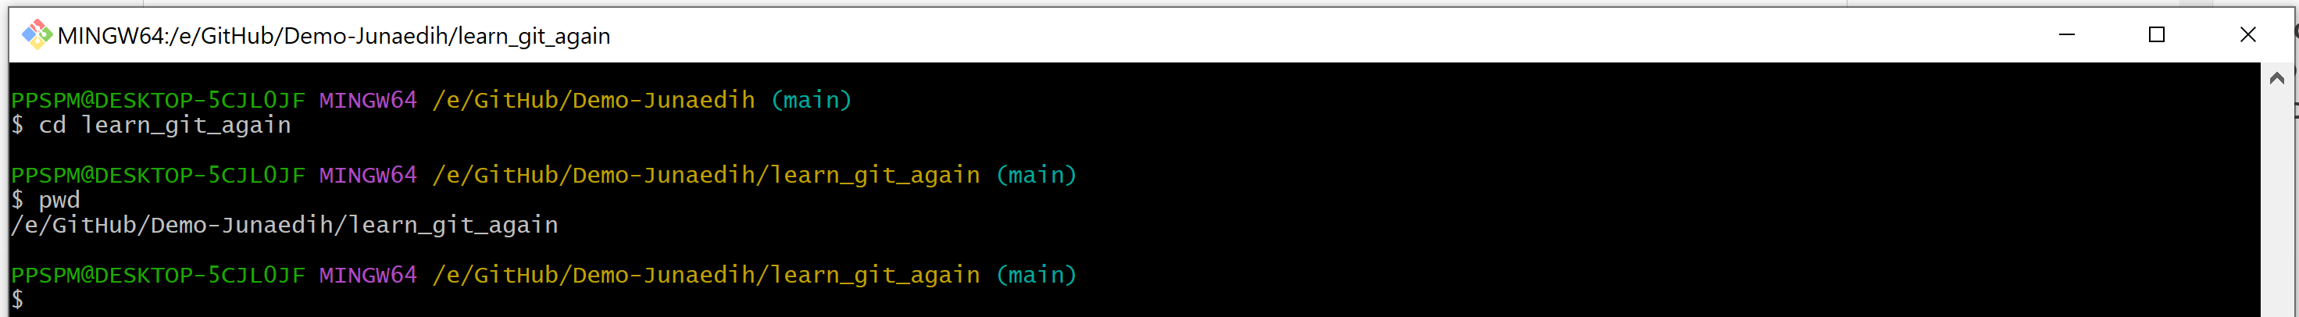

1. Create a file called third.txt.

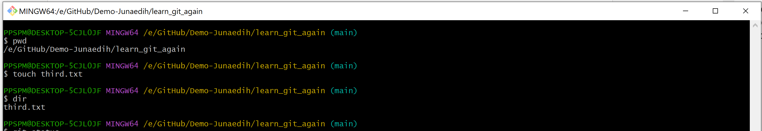

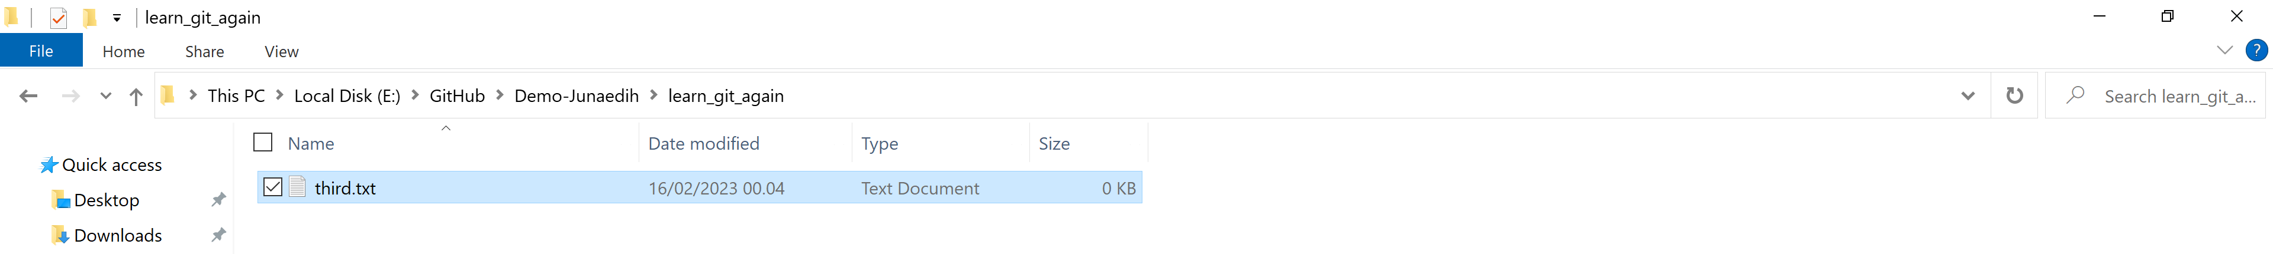

1. Initialize an empty git repository.

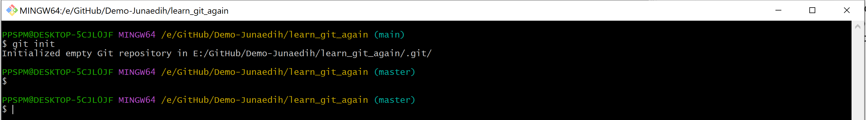

1. Add third.txt to the staging area.

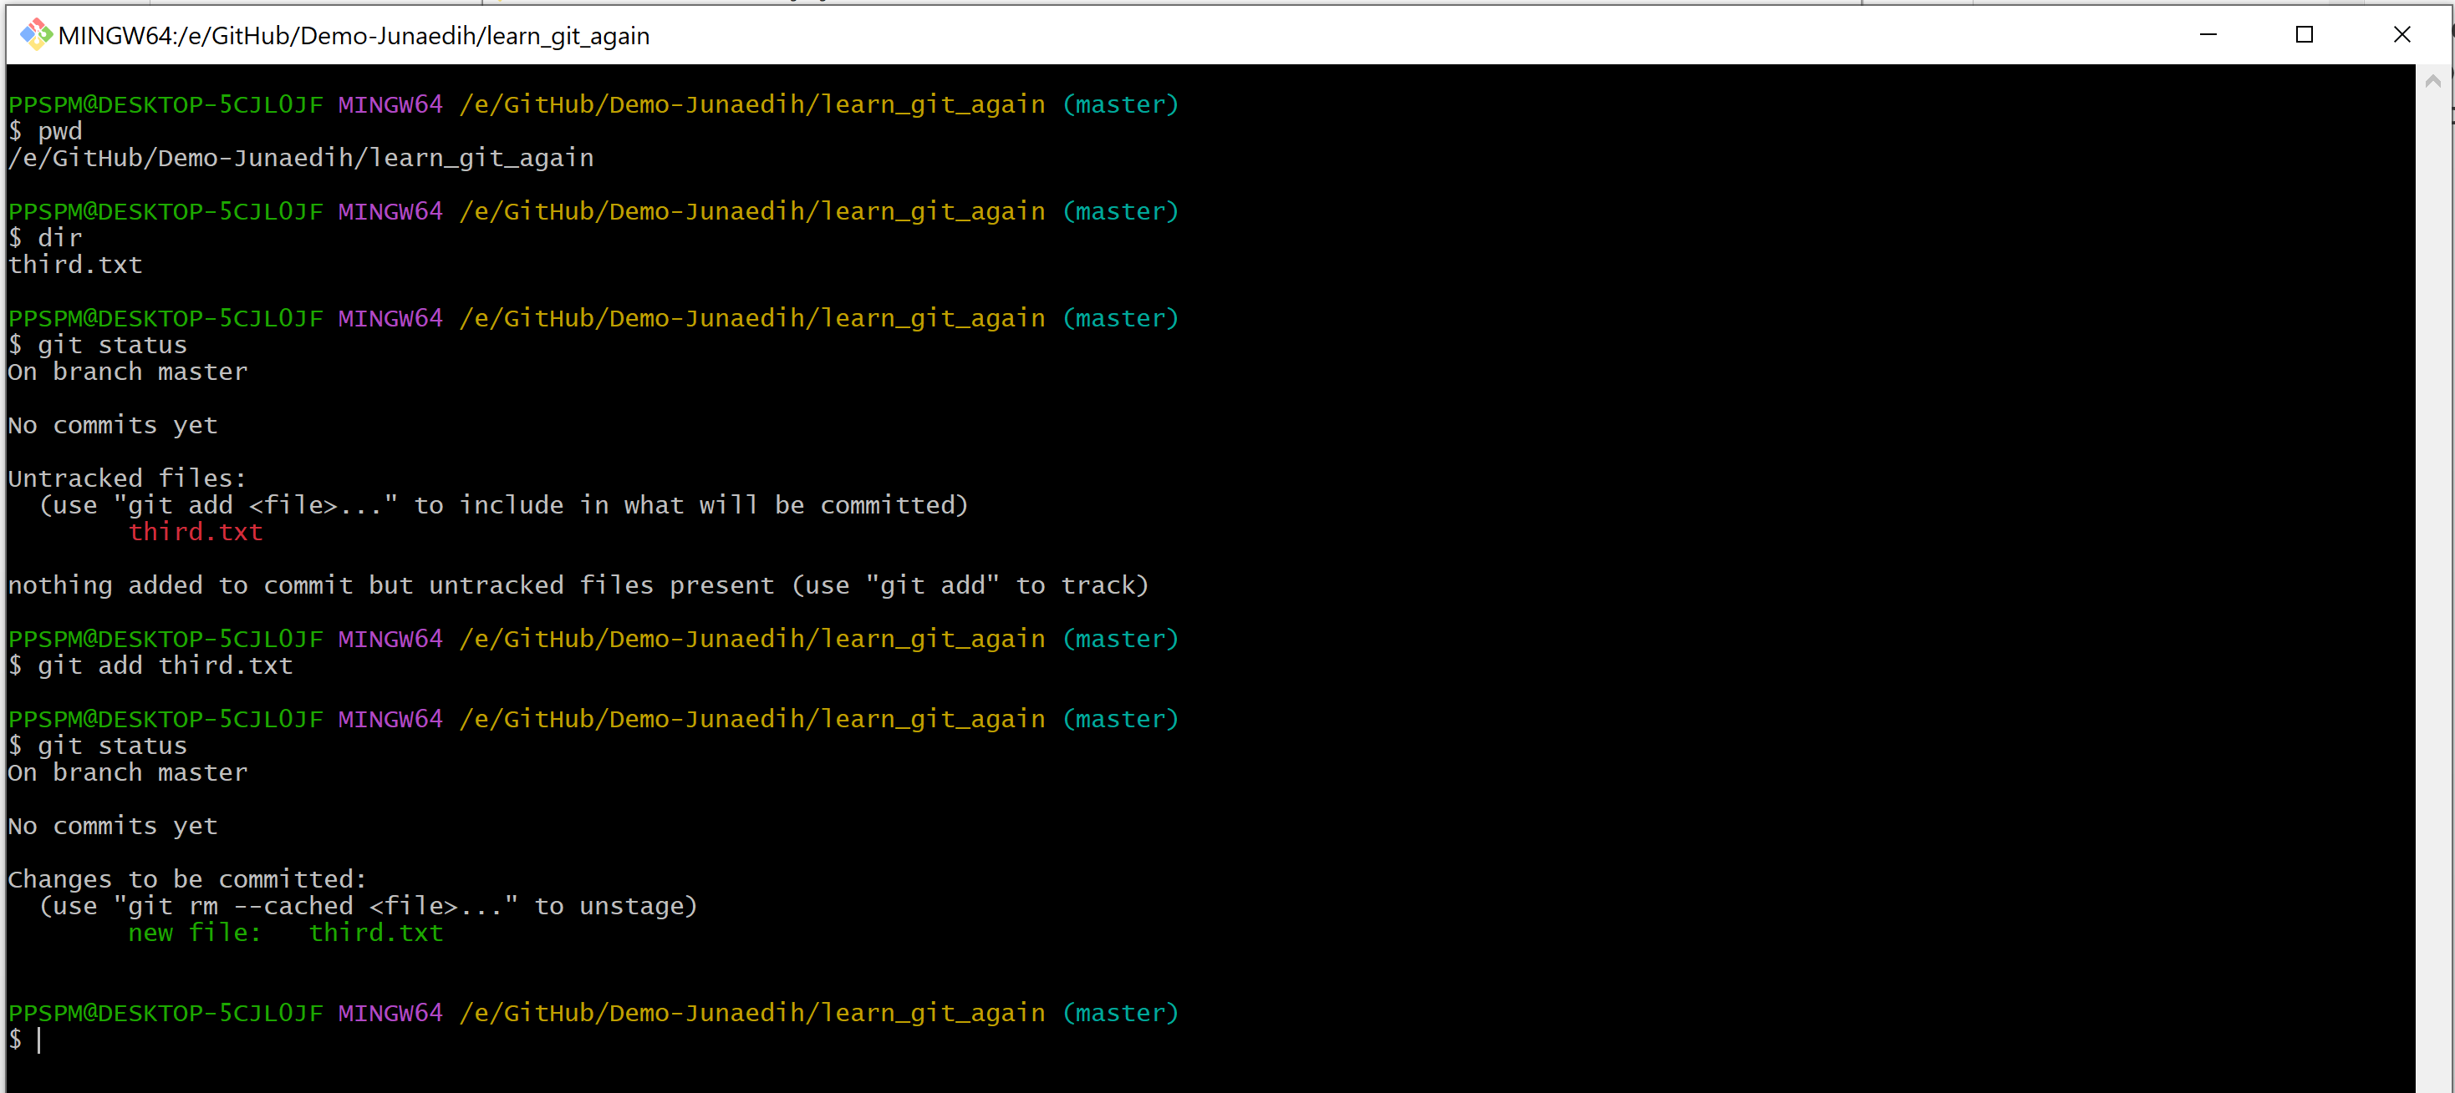

1. Commit with the message "adding third.txt".

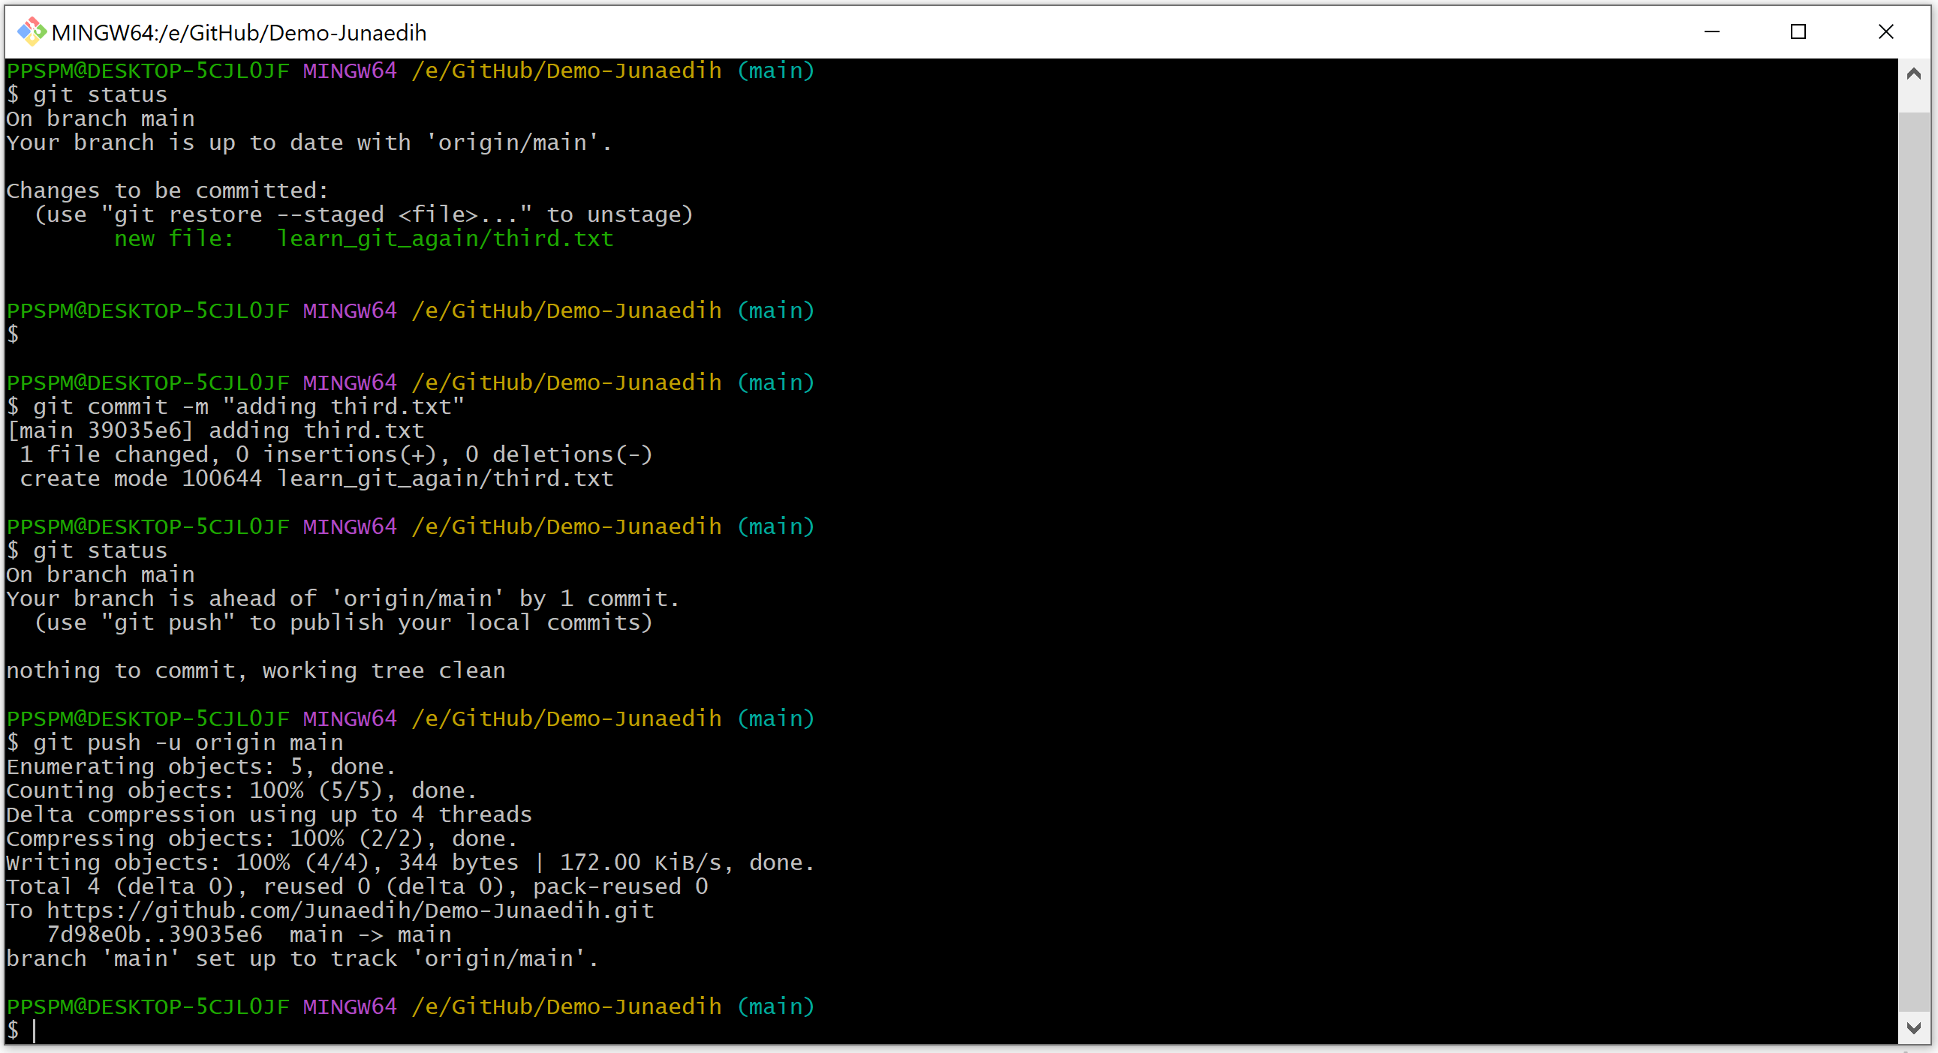

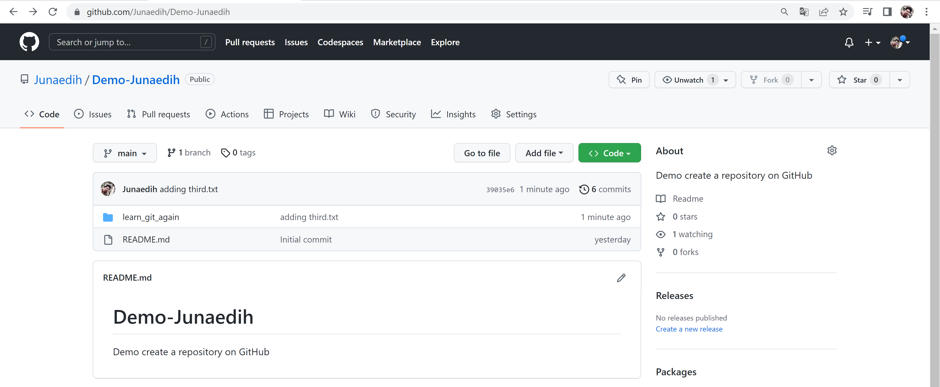

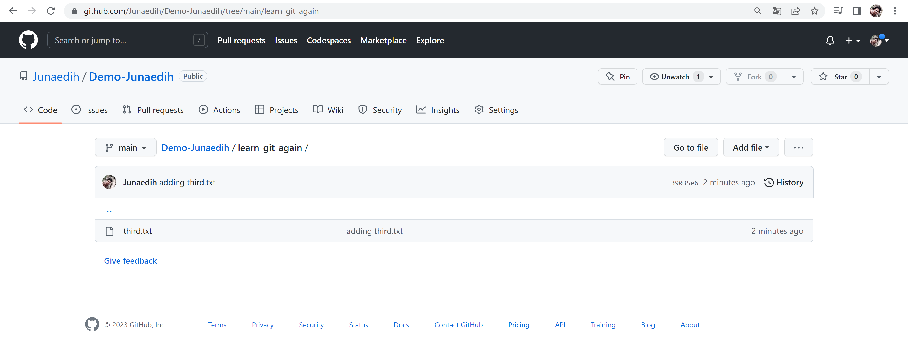

1. Check out your commit with git log.

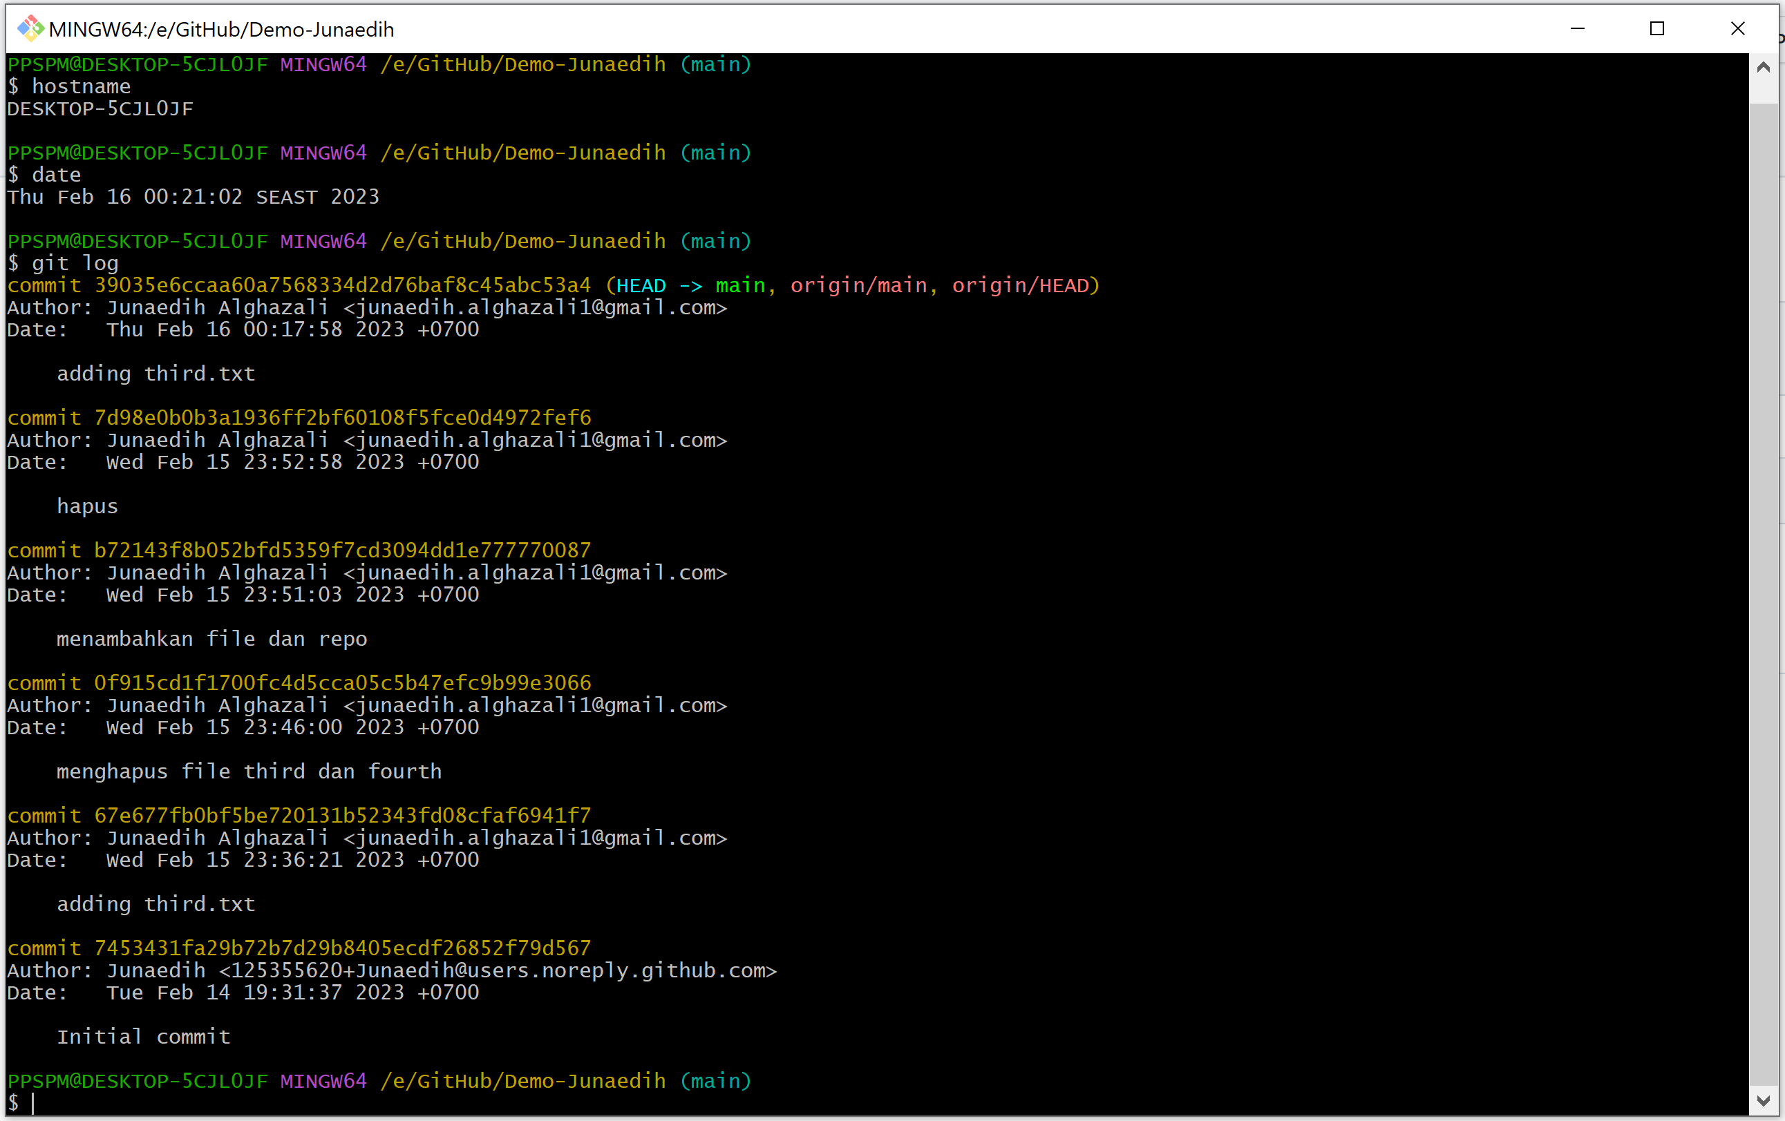

1. Create another file called fourth.txt.

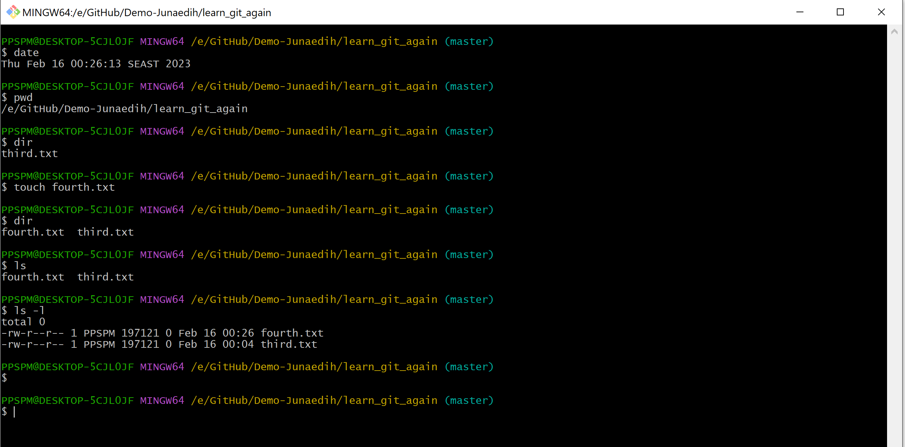

1. Add fourth.txt to the staging area.

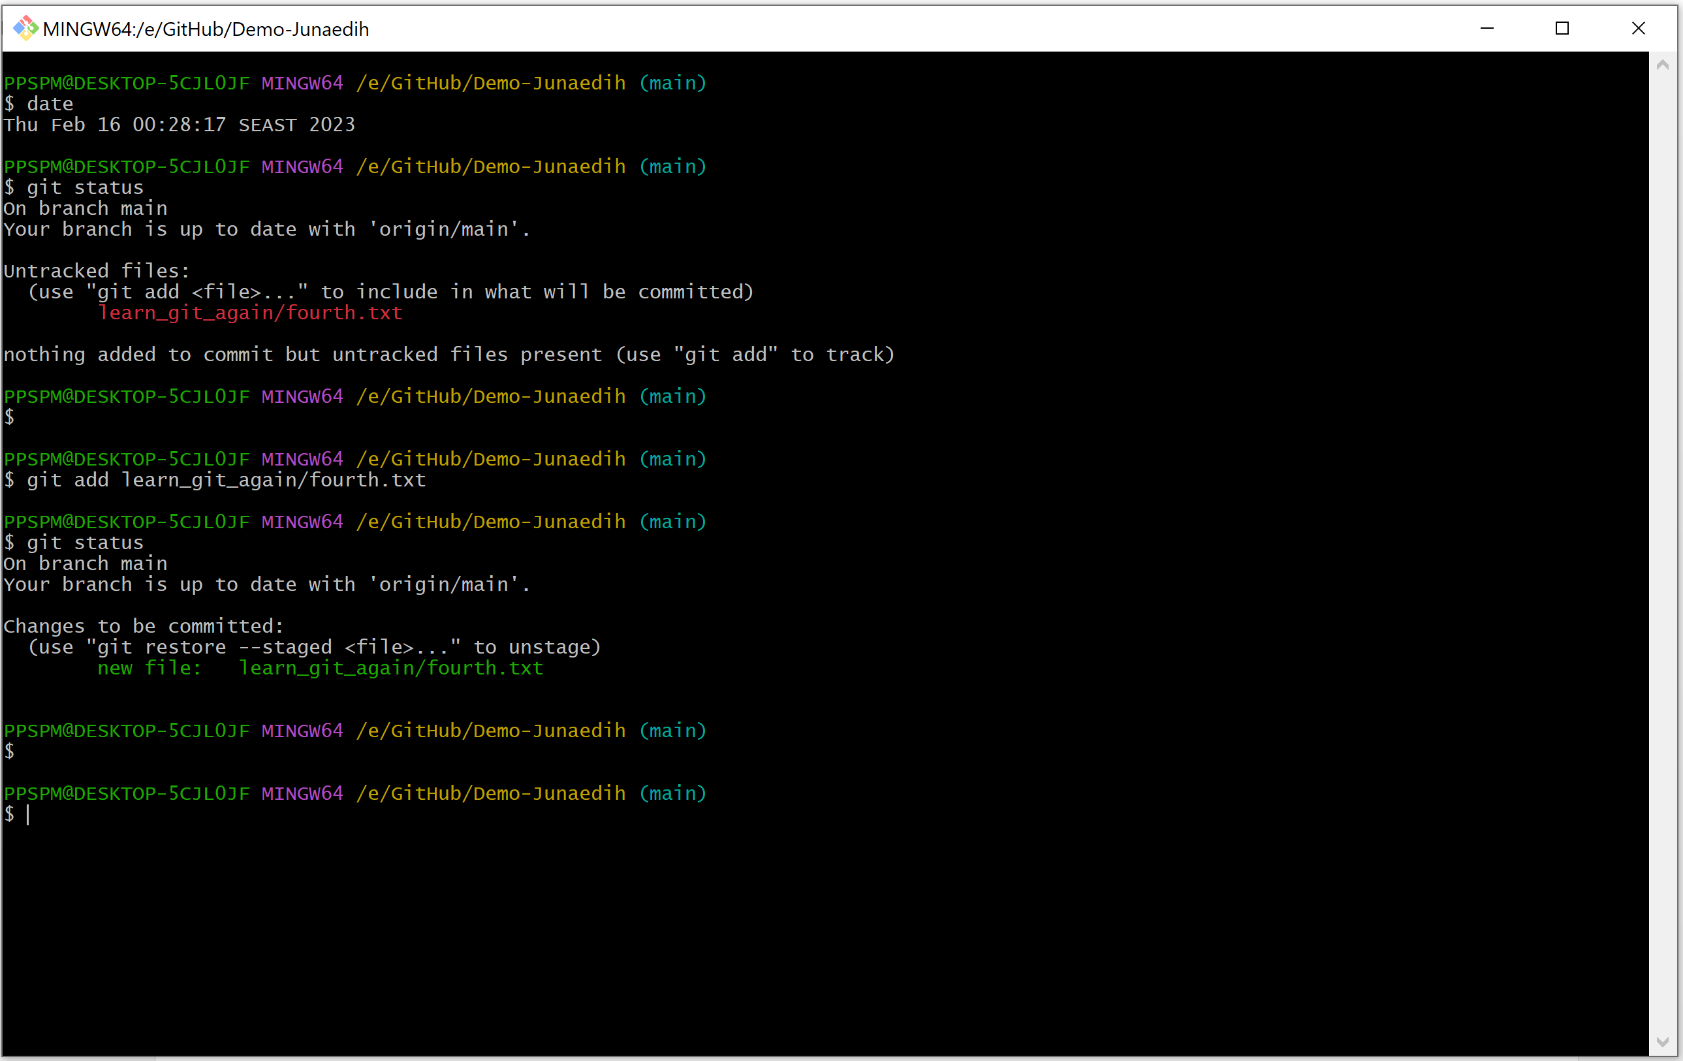

1. Commit with the message "adding fourth.txt"

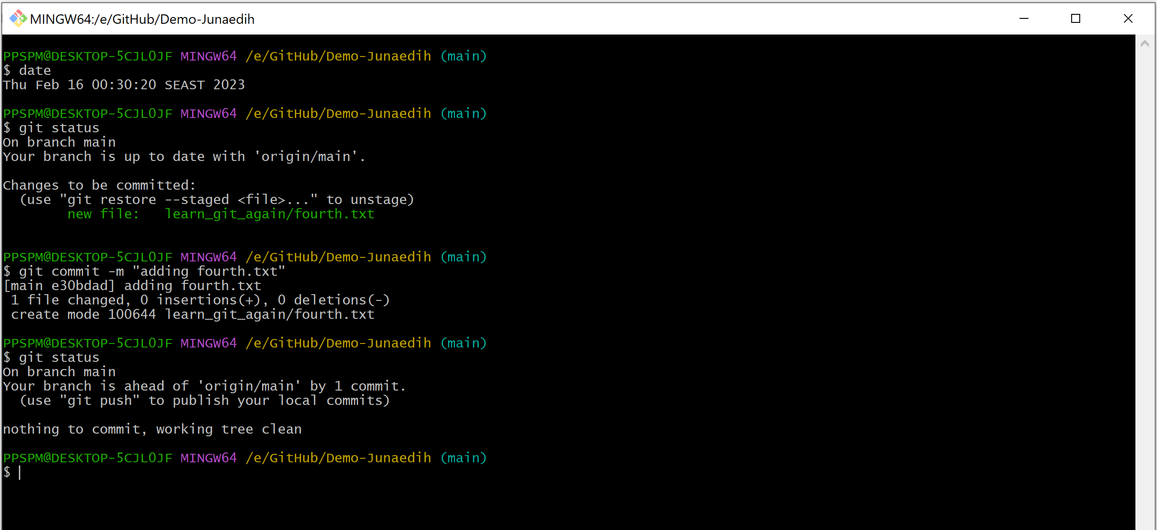

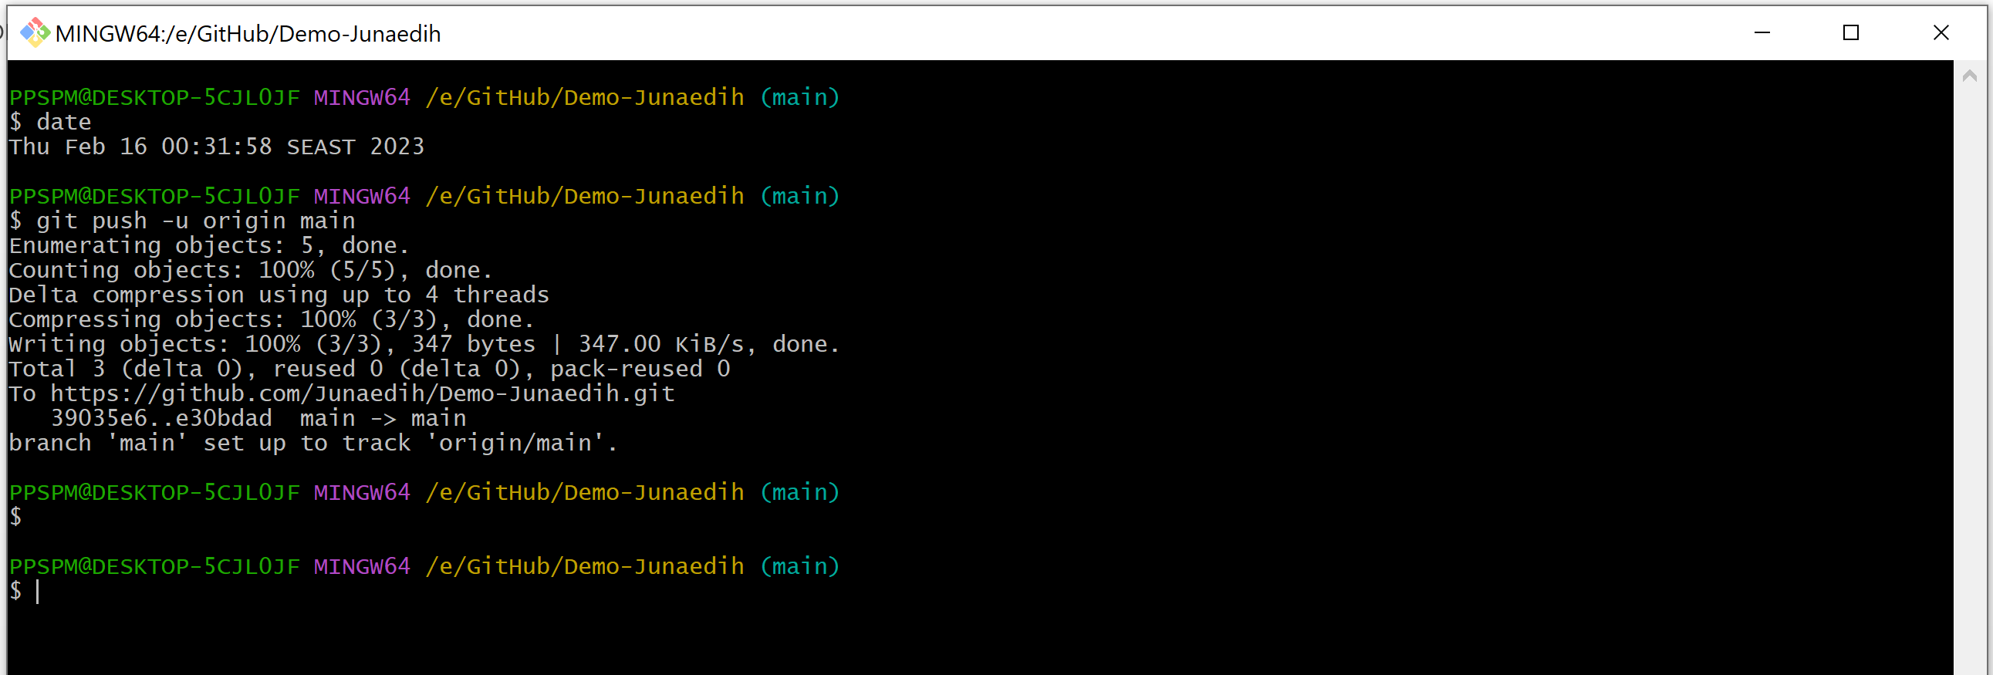

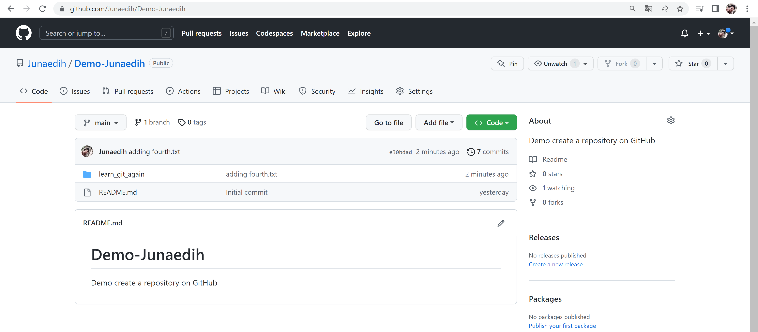

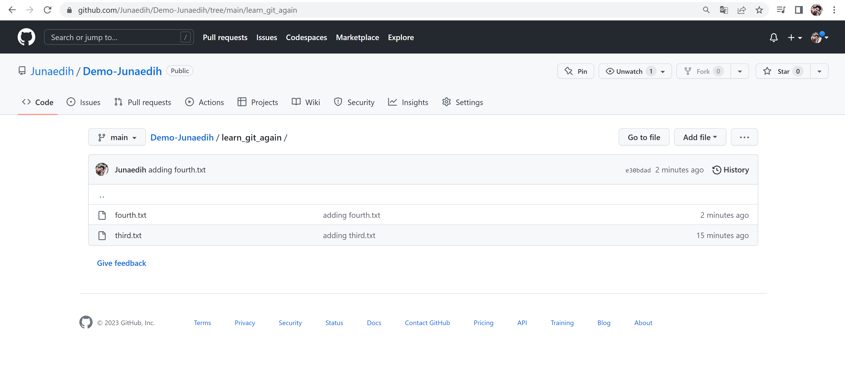

1. Remove the third.txt file

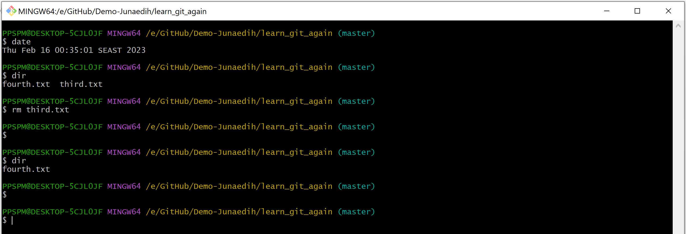

1. Add this change to the staging area

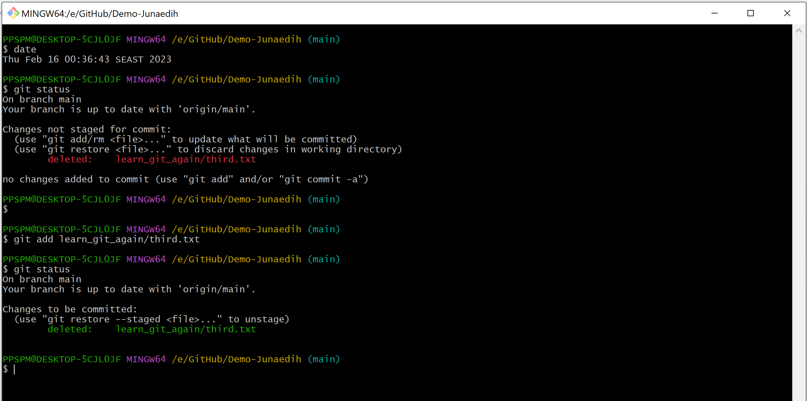

1. Commit with the message "removing third.txt"

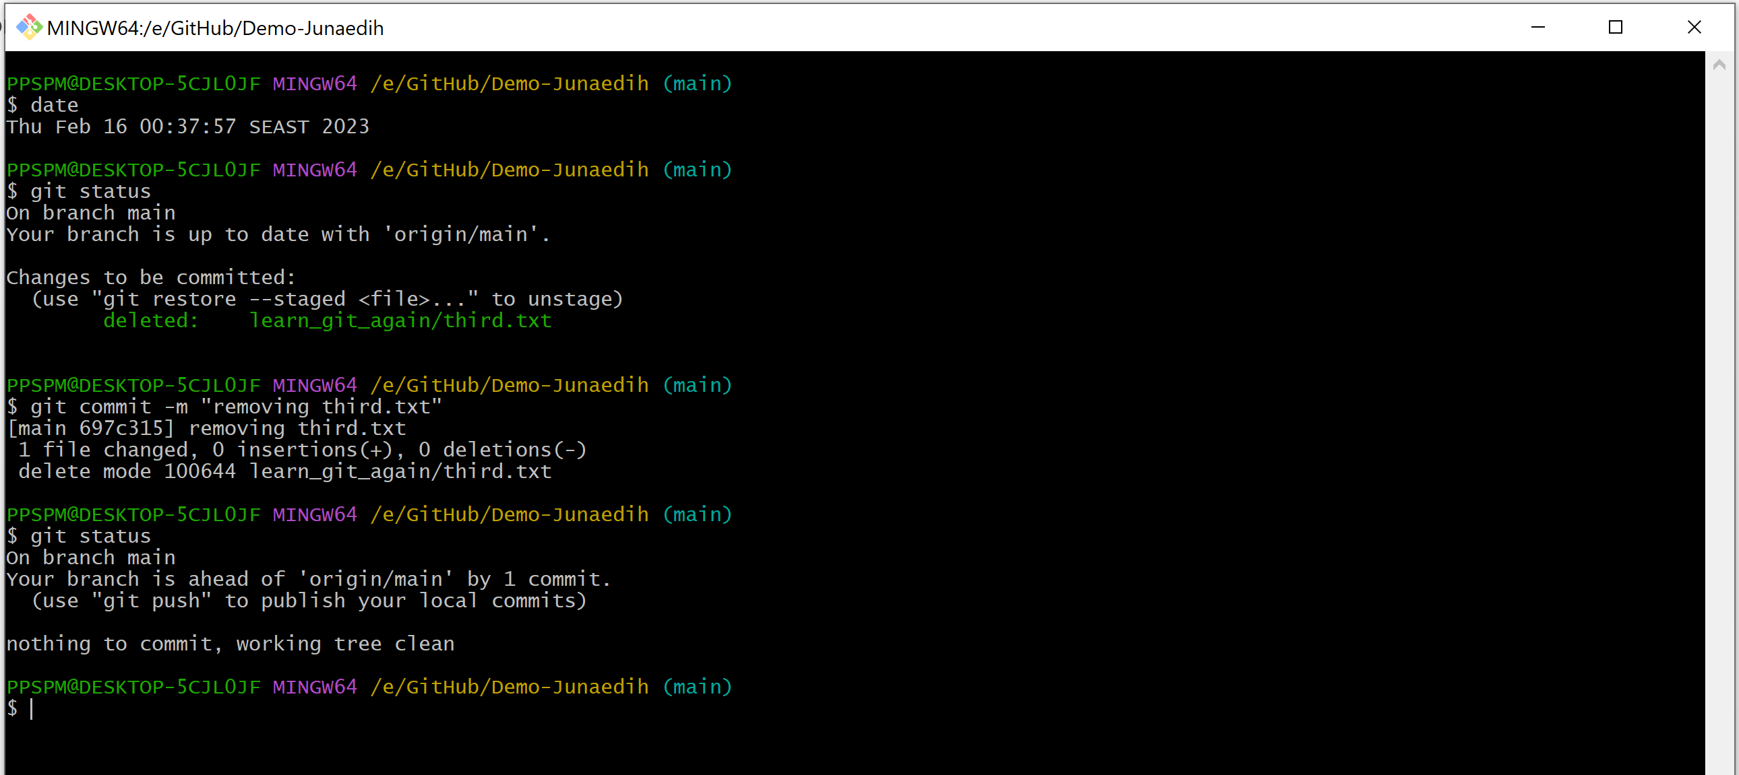

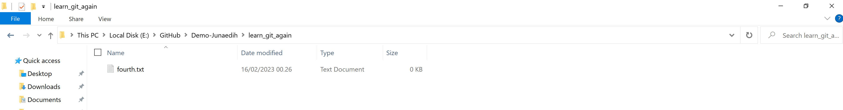

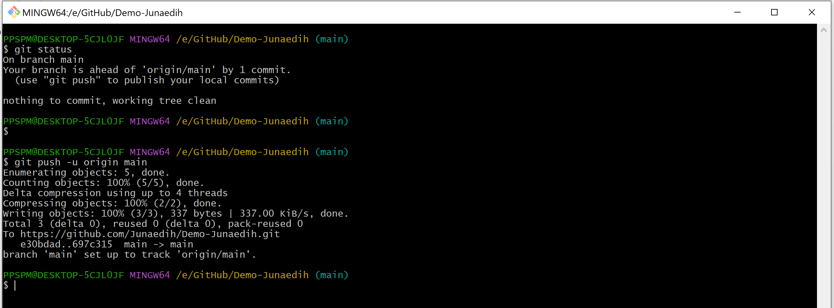

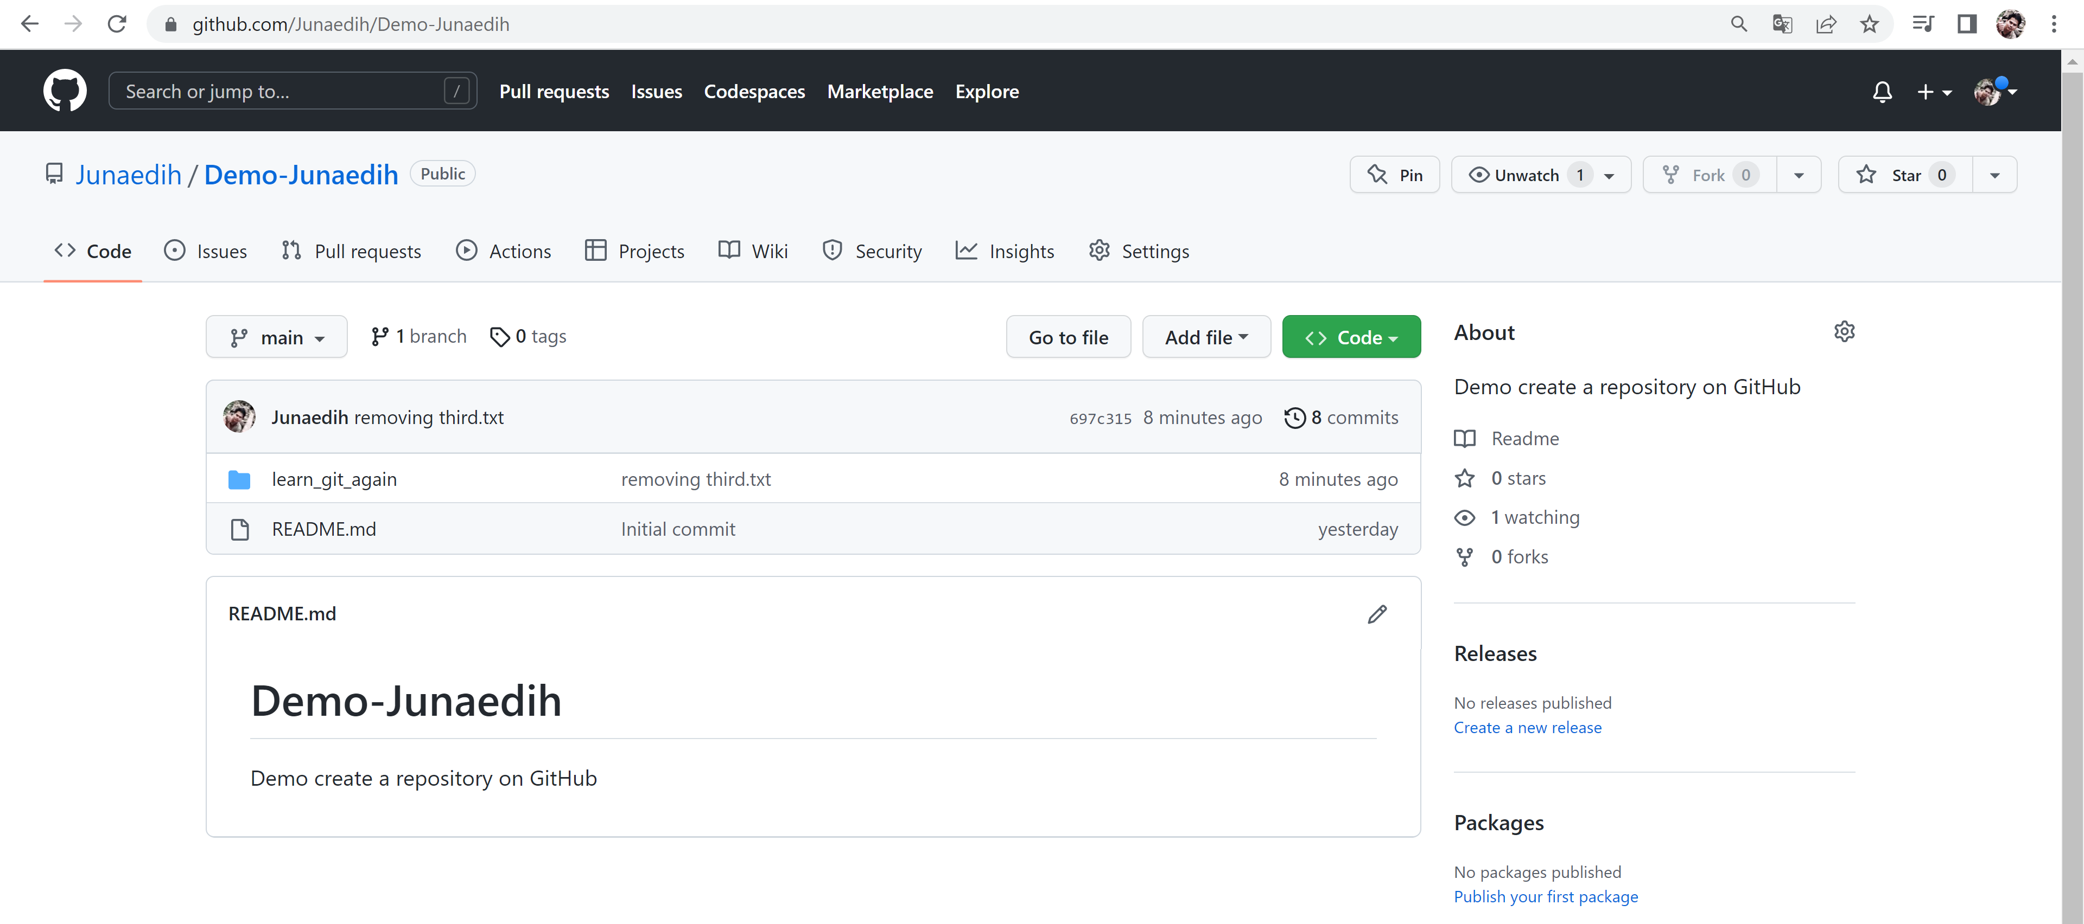

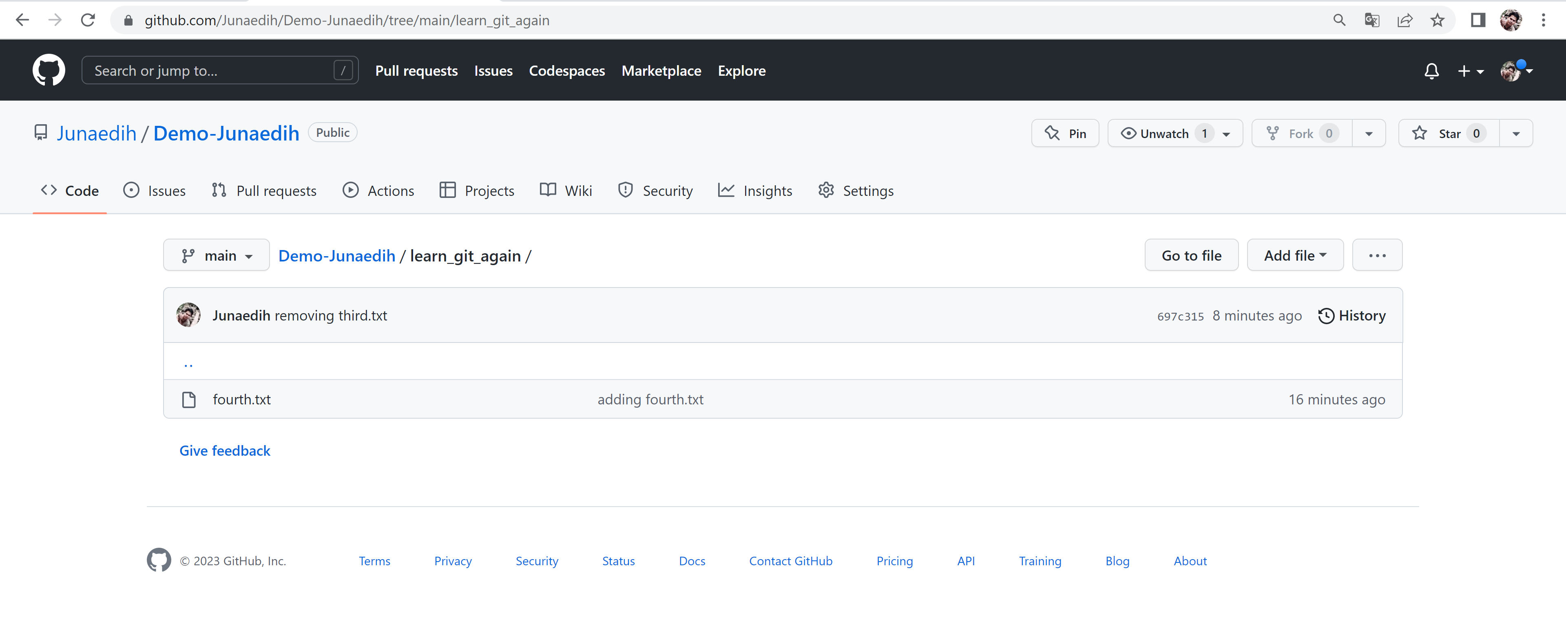

1. Check out your commits using git log

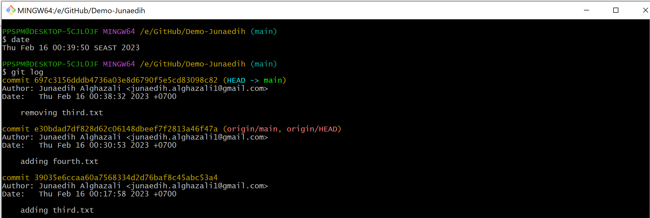

1. Change your global setting to core.pager=cat - you can read more about that here.

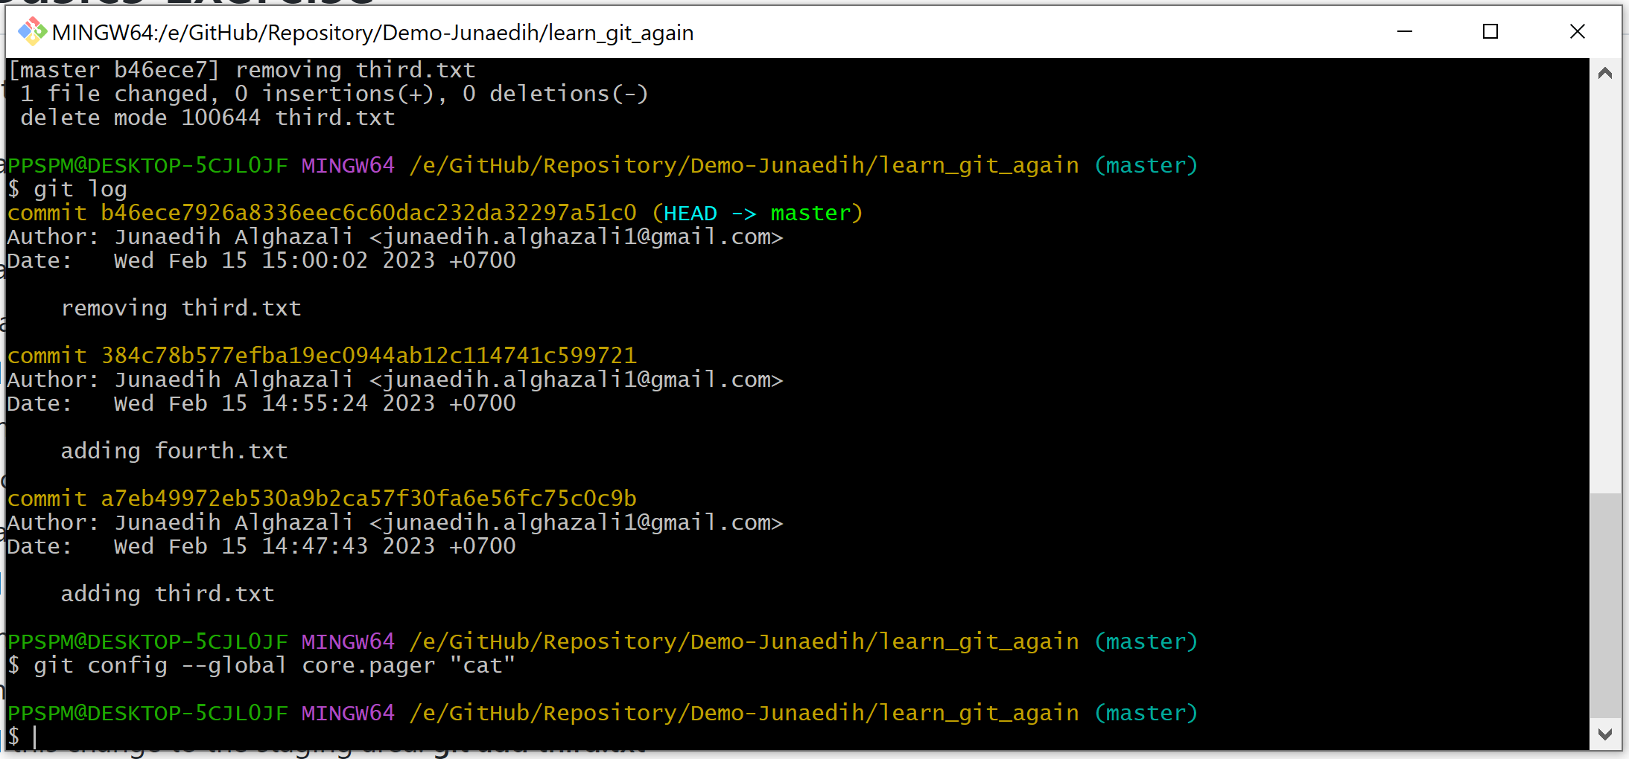

1. Write the command to list all of the global configurations for git on your machine. You can type git config --global to find out how to do this



   